Fish and Water Management Test Review

Multiple Choice

- This type of lure dives and rise as you reel in and stop reeling

  - Crankbait

- These ar type of sinker/weight discussed in

  - Sliding
  - Splitshot
  - Drop shot

- Spoon lures use what to catch fish?

Vibration and Light

- When should a jig type lure be used?

  - Low Movement Fishing

- This guides the line back onto the spool on a baitcast reel?

  - Level Wind

- This fish is illegal to stock in Texas and 34 other states?

  - Diploid Grass Carp

- This fodder fish should be removed whenever caught due to dangers of overpopulation?

  - Bluegill

- What can be put in a pond to clear muddy waters?

Hay Bales

- Noodling is illegal in Texas
  - No

- Aeration equipment
  - Adds Oxygen to water

11.________ owns public waters
  - Government

- This is how long you should wait to fish a stocked pond
  - 12 Months

- Why? (from 14)

To give the fodder fish a chance to set up a habitat and reproduce

- What is a trot line and how is it set up?

A line is attached to two stationary point. Attach a brick and a float in the middle. Then attach hooks and bait.

- Why are floating commercial feeds used?

So we can monitor fish activity

- What is the difference between red ear sunfish and bluegill when it comes to stocking?
Blue Gill will overpopulate a pond while a red ear will not

- What are differences between the diploid and triploid grass carps?
Dipolid can reproduce, overpopulate a pond, and destroy a habitat. Diploid are illegal to stock in Texas. Triploid can not reproduce and can be stocked in limited numbers in Texas

- What are two fishing knots discussed in class and how are they used?
Palomar, Improved Clinch, or Blood Knot

- What does stocking rate mean?
How many fish can be stocked without damaging the habitat

- What are the steps to stocking a pond from scratch?
Kill all unwanted fish
Add bait fish. Wait 6-12 months
Add predator fish (bass) wait 12 months
Fish Pond

31-35. Identify the following lures and equipment.

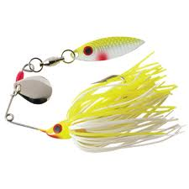
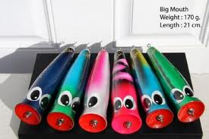
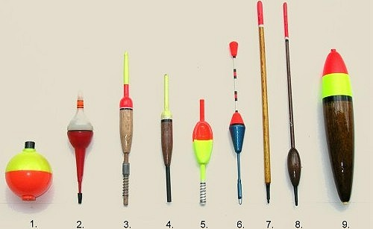

31.__Top Water_______ 32.__Floats/bobbers_ 33.__Spinnerbait_

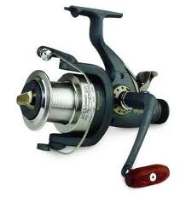
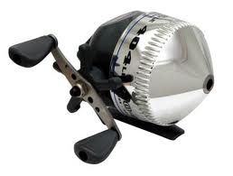

34.___Spincast reel_____ 35._Spinner_reel_____

Identification
Pictures on next page also

___C_____26. Spiny Dorsal Fin ____G___29. Lateral Line

____F____27. Anal Fin ____K2___30. Gills

___A___28. Operculum ____H2__31. Swim Bladder

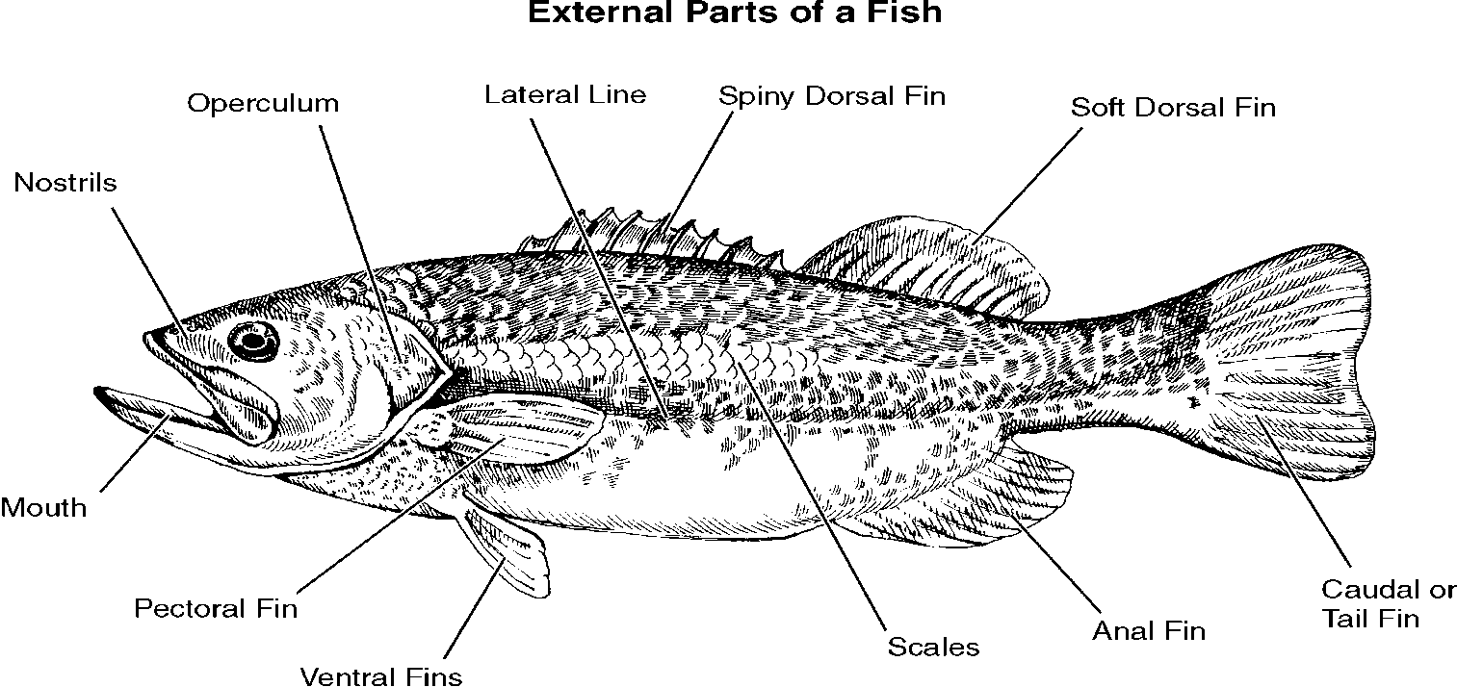
J.
K.
H.
G.
A.
B.
C.
D.
E.
F.
I.
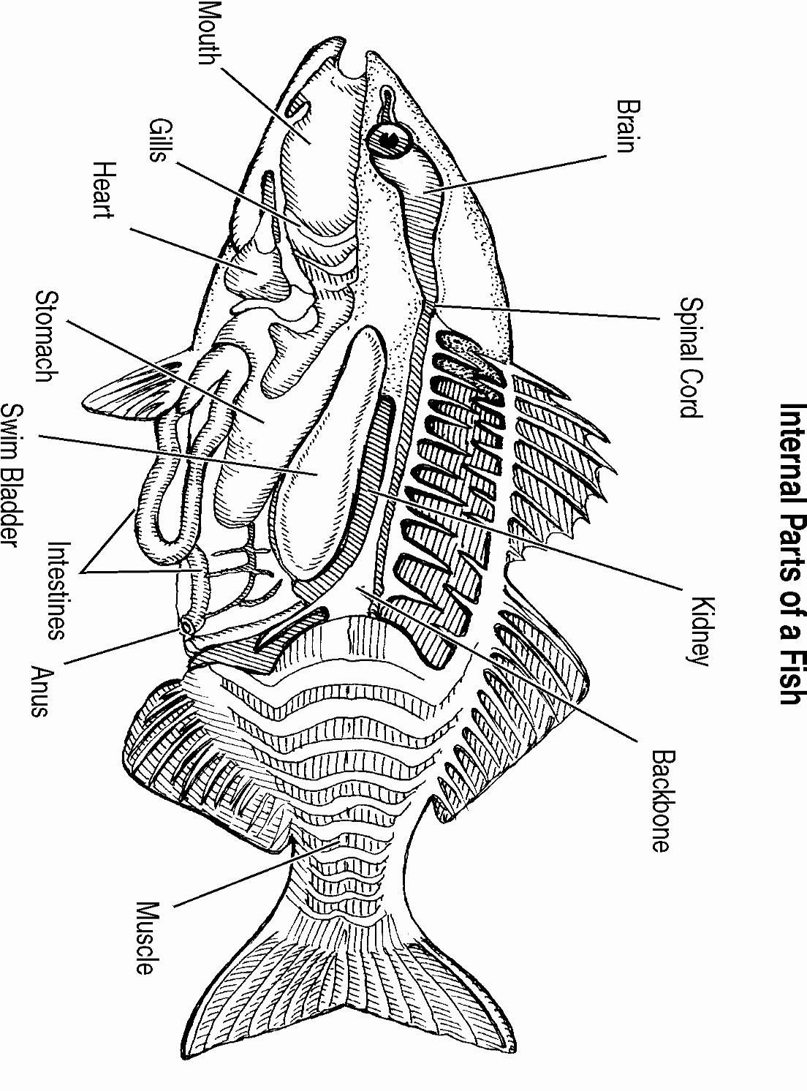
G2.
L2.
K2.
H2.
B2.
E2.
C2.
I2.
D2.
A2.
J2.
F2.

