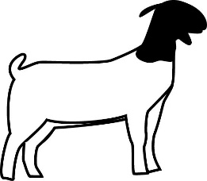
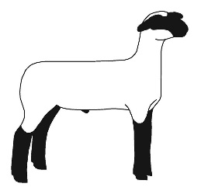
Plano FFA Sheep/Goat Projects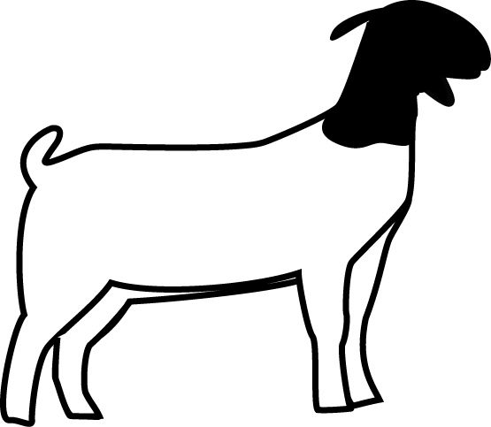
I. Purchase
-$400-$800, We can easily spend much more if you desire (Recommend:$500)
-Payment in cash or check NO later than Thursday, September 19th
- Once animal is purchased you will receive a phone call from Ms.Sandifeer or Ms. Navarrette. You should then make sure the animal is fed and has access to water.
-You will be responsible for preparing pen and having feed ready before sheep or goat arrives at the barn.
II. Fees
-$20 validation tag (Required to show at county & major show) (Due: ASAP)
-After Friday it will be $40 for a late tag.
-$40 Worming/Vaccination/Antibiotic charge (Due: at time of animal payment, if not before)
-$20-$40 jackpot show entry (about one per month) (Due: each show varies-either at the time of show or a couple weeks early)
-$20-$30 major show entry fee (Due: Special November meeting)
-$70-$100 hotel fee for major show (if parent attends, student can stay with parents; or if parent brings student down just for show day NO hotel expense.) (Due: prior to leaving for show)
III. Housing
-Project center: Spring Creek & Alma (By Clark Stadium)
-Pen Provided (Will have 1 assigned pen mate)
-Pen cleaned daily
-Barn cleaning schedule set by teacher-requires students to clean every 2-3 weeks
IV. Feed
-Feed purchased through Farmersville Grain and Hardware (you will have to call and set up student account with payment information) (972-784-7261)
-Feed order must be placed to teacher by Wednesday @ noon
-50lb bag - $25-$30
-Animal will be on self-feed until teacher instructs for hand feeding
-When instructed (7 AM & 7 PM best) (can exchange responsibilities) -The type of feed will change as the animal grows
V. Supplies
-Storage container (hold all supplies/equipment)
-Feed can (Metal one-pound coffee can) or Scoop
-Feeder( Clip on or pan)
-Brush (One for everyday use and One for show)
-Show stick
-Towels
-Shampoo
-Skin conditioner (spray, coconut oil,etc...)
VI. Time Required
-Twice daily feedings
-Exercise (walking)
-Bathing
VII. Shows
-Jackpot Shows-Typically one per month. Not required, but highly recommended for student and animal growth and development as a showman
-County Show- Dates TBD at Meyers Youth Park(McKinney-North of 380 & Lake Forest intersection)If the animal is selected to “Make sale” the sale will be held on Saturday after the show.
-Major Show-Terminal Show (Animal will not return)
-Houston dates and schedule TBD
-San Antonio dates and schedule TBD
VIII. Transportation
-Anytime an animal leaves project center transportation will be provided by the teacher using a PISD truck and trailer.
-Students are also provided transportation in PISD vehicles. Although, we highly encourage parental involvement. If parents attend students are strongly encouraged to travel with their family and stay in their hotel. (This will help eliminate extra hotel expenses). This will also reduce the number of days the student is absent from school.
IX. Reimbursements
-Jackpot shows-For learning experiences only.(Occasionally a student will win entry fees back, ribbon, or possibly a belt buckle)
-County Show- If Selected to “Make sale” student could possibly earn $600-$1000 based upon amount raised by Friends and Family of Plano FFA buyers’ club.
-Major Show-Regardless of placing, student will receive market price for animal. $70-$150, Based upon market price at time of show. If student “makes the sale” at San Antonio, they will earn between $1000-$1500. (This is extremely difficult, but possible)
X. Plano Agriculture Scholarship Association (Buyers Group)
-Group will purchase students animal at the county sale if you are a member and in good standings.
-Meetings are held monthly at Clark High School
XI. Contact Info
Abby Sandifeer
E-mail: abby.sandifeer@pisd.edu
Office Phone: (469) 752-9367

